JANTA VIDYA MANDIR GANPATRAI RASIWASIA COLLEGE, CHARKHI DADRI
Faculty Profile

Department : ENGLISH

Name of Faculty |  | DR.ROSHAN LAL |  |  | 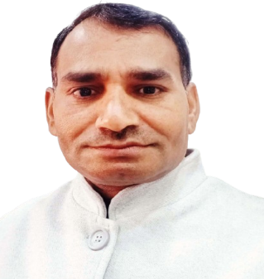
Department |  | ENGLISH
Designation |  | ASSOCIATE PROFESSOR
Experience |  | 16 YEARS
Contact No |  | 9466079813
Email Id |  | roshanlaljvm@gmail.com
Date of Joining |  | 07-08-2008
Educational Qualification
 | Name of Program |  | Year of  Passing | University
PG | M.A. English |  | 2003 | Kurukshetra University, Kurukshetra
Ph.D. | English |  | 2022 | J.J.T.U, Jhujhunu
Net | N/A
Other
Research Supervision/Guidance |  | NO
Research Publications
Books Published |  | ONE
Book Chapters |  | NO
Papers Presented in Conferences/ Seminar |  | International: 04 National: 25
Participated in Conferences/ Seminar |  | International: 02 National: 08
No. of Workshops/FDP/Training Programme Attended |  | 10
Major/Minor Research Projects |  | NO
Invited Lectures |  | 05
Awards/Honours |  | 08
Membership of Any  Professional/ Statutory Body |  | LIE MEMBERSHIP OF REDCROSS SOCIETY
Any Other Achievement |  | REGULAR BLOOD DONER

